# Eksamen 2021

Af Jesper Graungaard Bertelsen, AU-ID: au689481

Indholdsfortegnelse

Eksamen 2021 1

Opgave 1 2

a. Calculate the source entropy of this source 2

b. Apply the Huffman algorithm to this source and show the Huffman codewords for each symbol, then calculate the average codeword length of the Huffman code and calculate the efficiency of the source encoder. 4

c. A BSC channel with error probability 0.01, calculate the channel capacity Cs in bits per channel use. 5

d. If this DMS generates 1000 symbols per second, these symbols pass through this BSC channel which has maximum rate of s symbols per second. To be able to transmit the Huffman coded source symbols through the BSC, what is the minimum value of s. 6

Opgave 2 White Gaussian noise 7

a. Find the power spectral density and the autocorrelation function of n(t). 7

Opgave 3 9

a. Describe the resulting recovered signal if $fc=W$. Show your procedure. 9

Opgave 4 You are using a 4-ary PAM system to transmit binary data. As a pulse, you decided to use $sinc(2Wt)$. 11

a. Sketch the four waveforms that can be transmitted in this system. 11

b. Assign the four two-bit symbols to the waveforms. The assignment should minimize the probabilities of bit errors in noise. You may assume that all two-bit patterns are equiprobable. 12

c. Further analysis tells you that the symbol probabilities actually are: Pr[00] = 0.4; Pr[01] = 0.1; Pr[10] = 0.1; Pr[11] = 0.4. How can you map these symbols to waveforms such that the expected energy usage is minimized? 12

d. What is the expected energy usage with your assignment from (c)? Hint: start by finding the energy of the sinc pulse. 13

AU-ID ending with 1 solves problem 1, 2 & 3

## Opgave 1

Consider a discrete memoryless source (DMS) generate with alphabet {m0, m1, m2, m3} with probability (1/2, 1/4, 3/16, 1/16).

### Calculate the source entropy of this source

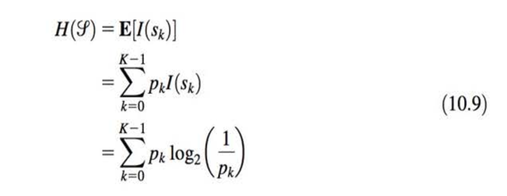The amount of information for a signal comes from log to the inverse of its probability

$$I\left(s_{k}\right)=\ln\left(\frac{1}{p_{k}}\right)$$

$$p≔\left(\begin{aligned}\frac{1}{2} \\ \frac{1}{4} \\ \frac{3}{16} \\ \frac{1}{16}\end{aligned}\right)$$

$$I_{S}=\log_{2}\left(\frac{1}{p}\right)≈\left(\begin{matrix}1 \\ 2 \\ 2,41504 \\ 4\end{matrix}\right)$$

The entropy tells us about the average information pr. symbol used.

===============

===============

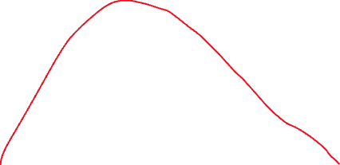

It doesn’t look like it ever reaches H(s) = 1.

### Apply the Huffman algorithm to this source and show the Huffman codewords for each symbol, then calculate the average codeword length of the Huffman code and calculate the efficiency of the source encoder.

Doing with percentages taken from 1/16 we know, that the total messages sent would be 16.

$m_{0}$ is asked for 8 times

$m_{1}$ is asked for 4 times

$m_{2}$ is asked for 3 times

&

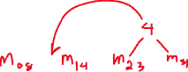

is asked for 1 time.

√

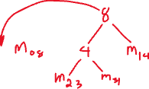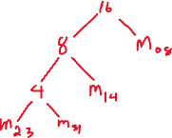

Then I know the codewords as

|  |  |  |
| --- | --- | --- |
| Message | Frequency | Codeword |
| $$m_{0}$$ | 8 | $$1$$ |
| $$m_{1}$$ | 4 | $$01$$ |
| $$m_{2}$$ | 3 | $$000$$ |
| $$m_{3}$$ | 1 | $$001$$ |

Total bits used will then be

===========================

Bits used to reference messages:

$8·1+4·2+3·3+1·3=28$

===========================

16 messages being referenced:

============================================

$\frac{28}{16}=1,75bits pr. referenced message in average$

============================================

*Efficiency*

If each message reference is off ASCII 8 bit standard, then a total of

$8·16=128$ bits would have been used.

========================================

$\left(1-\frac{28}{128}\right)·100=78,125$

The message bits has been reduced by about 80%

of what it would have had in ASCII bits, by

doing the huffman algorithm.

========================================

### A BSC channel with error probability 0.01, calculate the channel capacity Cs in bits per channel use.

I know that

$p\left(y_{k} | x_{j}\right)$, what’s the probability of $y_{k}$ given that $x_{j}$ has occurred. What’s the probability of the output being 1 in the case of the output being 0… and so on for every combinations. This sounds familiar.

$$p\left(y_{0} | x_{0}\right)=p\left(y_{1} | x_{1}\right)=p_{x0}p_{y0}=p_{x1}p_{y1}=1-p_{e}$$

$$p_{x0}p_{y1}=p_{x1}p_{y0}=p_{e}$$

$$p\left(x_{j}\right|y_{k})=x.y=\left\{\begin{matrix}p_{e} & 1-p_{e} \\ 1-p_{e} & p_{e}\end{matrix}\right\}$$

$$p\left(x_{0}\right)=p\left(x_{1}\right)=\frac{1}{2}$$

$$I\left(X;Y\right)=p\left(x_{0} | y_{0}\right)p\left(x_{0}\right)·\log_{2}\left(\frac{p\left(y_{0} | x_{0}\right)}{p\left(y_{0}\right)}\right)$$

$$+p\left(x_{0} | y_{1}\right)p\left(x_{0}\right)·\log_{2}\left(\frac{p\left(y_{1} | x_{0}\right)}{p\left(y_{1}\right)}\right)$$

$$+p\left(x_{1} | y_{0}\right)p\left(x_{1}\right)·\log_{2}\left(\frac{p\left(y_{0} | x_{1}\right)}{p\left(y_{0}\right)}\right)$$

$$+p\left(x_{1} | y_{1}\right)p\left(x_{1}\right)·\log_{2}\left(\frac{p\left(y_{1} | x_{1}\right)}{p\left(y_{1}\right)}\right)$$

Two successes and two errors.

$I\left(X;Y\right)=2·\frac{1-p_{e}}{2}·\log_{2}\left(\frac{1-p_{e}}{\frac{1}{2}}\right)+2·\frac{p_{e}}{2}\log_{2}\left(\frac{p_{e}}{\frac{1}{2}}\right)=\log_{2}\left(\frac{1-p_{e}}{\frac{1}{2}}\right)-p_{e}\log_{2}\left(\frac{1-p_{e}}{\frac{1}{2}}\right)+p_{e}\log_{2}\left(\frac{p_{e}}{\frac{1}{2}}\right)$

Or by matrix

$$x=\left\{\begin{aligned}p_{x0} \\ p_{x1}\end{aligned}\right\}, y=\left\{p_{y0}, p_{y1}\right\}$$

$$x.y=\left\{\begin{matrix}p_{x0}p_{y0} & p_{x0}p_{y1} \\ p_{x1}p_{y0} & p_{x1}p_{y1}\end{matrix}\right\}$$

$$I{\left(X;Y\right)}_{max}=\left\{\begin{matrix}\frac{p_{e}}{2} & \frac{1-p_{e}}{2} \\ \frac{1-p_{e}}{2} & \frac{p_{e}}{2}\end{matrix}\right\}.\left\{\begin{matrix}\log_{2}\left(2·p_{e}\right) & \log_{2}\left(2-{2p}_{e}\right) \\ \log_{2}\left(2-{2p}_{e}\right) & \log_{2}\left(2·p_{e}\right)\end{matrix}\right\}⋆\left\{\begin{matrix}1 & 0 \\ 0 & 1\end{matrix}\right\}$$

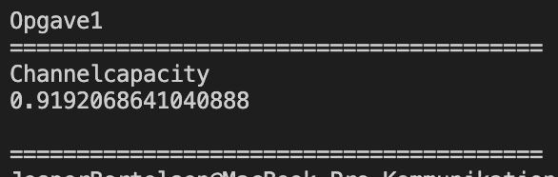===========================

$C_{s}≈0,9192$ bits pr. Channel use

===========================

### If this DMS generates 1000 symbols per second, these symbols pass through this BSC channel which has maximum rate of s symbols per second. To be able to transmit the Huffman coded source symbols through the BSC, what is the minimum value of s.

$$T_{s}=\frac{1}{1000}s$$

From the hoffman section I found out, that 1,75 bits are used for every symbol.

$1000·1,75=1750 bits pr. second$

$$\frac{sum\left(H_{s}\right)}{4}=sum\left(\left(\begin{matrix}0,5 \\ 0,5 \\ 0,45282 \\ 0,25\end{matrix}\right)\right)·\frac{1}{4}=\left(2·\frac{1}{2}+0,45282+\frac{1}{4}\right)·\frac{1}{4}=0,425705$$

Using this as an average entropy, I then get:

$$\frac{0,425705}{0,001seconds}≤\frac{0,9192bits pr. channel use}{T_{c}}$$

The variable s in symbols pr seconds is the invertible of seconds pr. Symbol aka TC here.

$$\frac{0,425705}{0,001seconds}≤\frac{0,9192bits pr. channel use}{\frac{1}{s}}$$

$$\frac{0,425705}{0,001seconds}≤0,9192bits pr. channel use·s$$

$$\frac{0,425705}{0,001seconds}=425,705$$

Minimum value of s would occur at

$$\frac{425,705}{seconds}=0,9192bits pr. channel use·s$$

$⇕$*Ligningen løses for s vha. WordMat.*

$$s=463,126$$

===========

$s=463,126$

===========

## Opgave 2 White Gaussian noise

White Gaussian noise of zero mean and power spectral density N0/2 is applied to the filtering scheme shown in Figure 1. The noise at the low-pass filter output is denoted by n(t)

### Find the power spectral density and the autocorrelation function of n(t).



Power spectral density of the output from the density to the filter squared times the power spectral density of the input.

Let me look at the input.

Using eq. 5.74

$$R_{X}\left(τ\right)=\frac{1}{2}·\cos\left(2πf_{c}t\right) <- A=1$$

$$R_{X}\left(τ\right)=\frac{\cos\left(2πf_{c}τ\right)}{2}$$

$$R_{X}\left(τ\right)=\frac{1}{2}·\frac{1}{2}·\left[e^{j2πf_{c}t}+e^{-j2πf_{c}t}\right]$$

Following the procedure of example 5.10 I get:

Assuming linearity exists in the input signal:

$$S_{X}\left(ω\right)=\frac{π}{2}·\left[δ\left(ω-ω_{0}\right)+δ\left(ω+ω_{0}\right)\right]$$

$$S_{X}\left(f\right)=\frac{π}{2}·\left[δ\left(ω-2πf_{c}\right)+δ\left(ω+2πf_{c}\right)\right]$$

Assuming that the power spectral densities can be added directly I have the output spectral as

Now let’s look at our transfer functions:



$=1^{2}\frac{π}{2}\left[δ\left(ω-2πf_{c}\right)+δ\left(ω+2πf_{c}\right)\right]$

==================================

$S_{n}\left(f\right)=\frac{π}{2}\left[δ\left(ω-2πf_{c}\right)+δ\left(ω+2πf_{c}\right)\right]$

==================================



As I know the power spectral density of the output, I can do it’s inverse fourier transform and get it’s autocorrelation function

$$S_{n}\left(f\right)→^{F^{-1}}R_{n}\left(f\right)$$

$$R_{n}\left(t\right)=\cos\left(2πf_{c}t\right)$$

The variance can then be calculated at the time period 0.

==============

$R_{n}\left(0\right)=σ^{2}=1$

==============

## Opgave 3

In DSB-SC systems, we assume that the carrier frequency, fc is much larger than the bandwidth of the low pass message signal (W ). Let us assume a m(t) with the power spectral density depicted in the figure part (a). Let us also assume the use of a standard DSB-SC product modulator as shown in following figure part (b) and a coherent demodulator with perfect synchronization. Finally, assume an ideal low-pass filter is used for reception (bandwidth W).

### Describe the resulting recovered signal if $f_{c}=W$. Show your procedure.

Doing the inverse fourier transform of the message signal might help me with the system.

It can be proved, that a triangle signal with width 2W and a max height of two can be accomplished with convolution of two rectangle signals with widths W and heights of $\frac{1}{\sqrt{w}}$.

$$x\left(f\right), h\left(f\right)=\frac{1}{\sqrt{w}}·rect\left(\frac{f}{w}\right)$$

$$x\left(f\right)⋆h\left(f\right)=\int_{-∞}^{∞}{x\left(τ\right)h\left(f-τ\right)dτ}$$

As these are the frequency representations and as I know, that a convolution in frequency domain equals the product in time domain, the triangle can be expressed as

As they are equal I only have to do it for one.

$$x\left(f\right)→^{F^{-1}}x\left(t\right)$$

I have written it form of the frequency only.

## Opgave 4 You are using a 4-ary PAM system to transmit binary data. As a pulse, you decided to use $sinc(2Wt)$.

### Sketch the four waveforms that can be transmitted in this system.

With a 4-ary PAM system the inputs can be sampled as.



Using gray code for minimizing the bit errors, as only bit is switched when going to the nearest level.



My 4 waveforms I choose to be

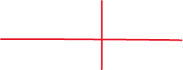

As the zero crossings are met at $k·\frac{π}{2W}$, I will make a gitter for every $\frac{π}{2W}$.

I’m using bipolar to minimize the maximum magnitude of voltages used, therefore being more power efficient.

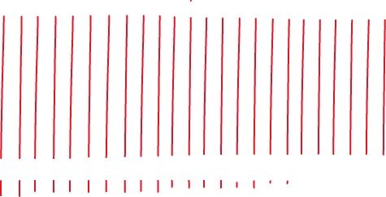

### Assign the four two-bit symbols to the waveforms. The assignment should minimize the probabilities of bit errors in noise. You may assume that all two-bit patterns are equiprobable.

This I’ve already done in last question

$s_{1}\left(t\right)=-3V·\operatorname{sinc}\left(2Wt\right)→00$ $s_{2}\left(t\right)=-1V·\operatorname{sinc}\left(2Wt\right)→01$ $s_{3}\left(t\right)=1Vsinc\left(2Wt\right) →11$ $s_{4}\left(t\right)=3Vsinc\left(2Wt\right) →10$

And what I did to minimize bit errors is, that the distant in bit switches is smallest, when going to a nearby level.

$-3V→-1V, 1 switch$

$-1V→1V, 1 switch$

$1V→3V, 1 switch$

Where I’ve chosen -3V, -1V, 1V, 3V

With a sinc function of 3V, the next wave top will be about 0,4. This means that for it to be recognized as a 11, which is the closest one to this level of voltage, would require about 0.6 V of noise.

### Further analysis tells you that the symbol probabilities actually are: Pr[00] = 0.4; Pr[01] = 0.1; Pr[10] = 0.1; Pr[11] = 0.4. How can you map these symbols to waveforms such that the expected energy usage is minimized?

If 00 and 11 is the symbols used the most, then I would be lukrative to put them about the zero crossing. $-1V, 1V$.

For minimizing bit errors I should then consider the level of the two others.

I chose that:

$s_{1}\left(t\right)=-3V·\operatorname{sinc}\left(2Wt\right)→10$ $s_{2}\left(t\right)=-1V·\operatorname{sinc}\left(2Wt\right)→11$ $s_{3}\left(t\right)=1Vsinc\left(2Wt\right) →00$ $s_{4}\left(t\right)=3Vsinc\left(2Wt\right) →01$

With this mapping I have saved on the energy usage, at the cost of a system more risk of bit errors.

### What is the expected energy usage with your assignment from (c)? Hint: start by finding the energy of the sinc pulse.

Let’s get to computing.

The energy of a signal can be expressed as an integral of the magnitude of the signal squared from minus infinity to infinity.

I was wondering about just estimating from which zero crossing the voltage of the sinc would be neglectable, but I can use another trick.

$$\int_{-∞}^{∞}{{\left|A_{i}sinc\left(2Wt\right)\right|}^{2}}dt→^{F} \int_{-∞}^{∞}{{\left|A_{i}rect\left(\frac{ω}{4W}\right)\right|}^{2}}df <-Parsevals theorem$$

Using the fact that a sinc function in the time domain is a rectangle in the frequency domain.

It’s width is 4w going from -2W to 2W and is zero elsewhere. As it’s the integral of a unit rect, it’s magnitude is just 1.

$$\int_{-2W}^{2W}{{\left|A_{i}\right|}^{2}}dω=2W\left|A_{i}\right|-\left(-2W\left|A_{i}\right|\right)=4W{\left|A_{i}\right|}^{2}W=4W{\left|A_{i}\right|}^{2}$$

$$E_{s_{1}}={\left|-3\right|}^{2}·4W=36W$$

$$E_{s_{2}}={\left|-1\right|}^{2}·4W=4W$$

$$E_{s_{3}}={\left|1\right|}^{2}·4W=4W$$

$$E_{s_{4}}={\left|3\right|}^{2}·\frac{2W}{π}=36W$$

Now having the values of energy for each signal.

I don’t know how many signals have been sent, but I know what the probabilities are for one signal to be sent. So let me find the average energy pr. Signal.

$$μ_{E_{s}}=E_{s_{1}}·0,1+E_{s_{2}}·0,4+E_{s_{3}}·0,4+E_{s_{4}}·0,1=3,6W+1,6W+1,6W+3,6W=10,4W$$

So I’m expecting an energy usage of 10,4 times it’s the W value.